CIS/STA 3920, 7-15-20 Prof. L. Tatum

Lecture Notes 2: Exploring Stock Data in R

TABLE OF CONTENTS

Section Topic
1 Introduction to Data Mining
2 Selecting, Downloading, and Transforming Stock Data
3 Uploading Your Stock Returns to R
4 Time Series Plots and Histograms in R
5 Exercises

Section 1: Introduction to Data Mining
One simple description of data mining is to say that it attempts to extract information from large data sets. That information will be of a statistical nature, not some rigid set of facts. And, it will be forward-oriented. For example, we will not be seeking to find the zip code of a particular customer, nor to find out which of 20 customers in that zip code bought Brand X coffee after being offered a 25% discount. Rather, our interest is towards future behavior, meaning we would be looking for the best way to estimate the percentage of customers in a zip code who would buy Brand X coffee when offered a 25% discount. That is how data mining (and statistics) differs from simply storing and retrieving data concerning customer transactions.
Please note that I have not claimed that we can actually forecast exactly who will do what in the future. Our forecasts will be about groups of people who share similar characteristics.
Likewise, when studying stock market prices, no statistician (or any person with real knowledge) will try to forecast the exact closing price of a particular stock tomorrow. That is entirely unrealistic, even foolish. That would be like trying to predict the spin of a roulette wheel – gamblers do that, and they suffer for it.
For stock market data, a typical goal of mathematical analysis would be to extract information from past data about the characteristics of the probability distribution of the percentage change of the closing price of IBM. That information will take the form of summaries of observed percentage changes, which we treat as estimates of underlying characteristics. “Today’s daily return” means the same thing as the “percentage change between today’s closing price and yesterday’s closing price.” That sort of information is very much needed for tasks such as options pricing.
There are four major characteristics of the probability distribution of the daily return on a stock that need to be addressed:
- Is there evidence that such an underlying probability distribution even exists?
- If so, what is the shape of that distribution?
- What is our best estimate of the expected value (μ) of that distribution?
- What is our best estimate of the standard deviation (σ) of that distribution?

We will find that the answers to those questions are not simple. For example, while we will see that a histogram of daily returns resembles a bell-curve, we will also find that this particular bell-curve differs in profound ways from a Normal distribution. Most importantly, the histogram shows strong evidence that the underlying probability distribution produces extreme outcomes more often than would a Normal distribution; we say the distribution has long tails.
We will also see that some of the most important information that we can extract concerns relationships between variables: in particular, it is of grave importance in Finance to estimate the strength of the relationship between the daily return on a given stock and the daily return on the S&P: that is a fifth consideration that should be added to the above list. One measure of that relationship is termed the “Beta” in finance: that is actually the sample slope found by regressing the returns on a stock against the returns on S&P500.
Daily returns (and monthly returns) on stocks are frequently use as examples in the data mining literature, including in the text Introduction to Statistical Learning, “ISLR”, by James, Witten, Hastie, and Tibshirani. Here is a graph from page 3 of ISLR where box plots are used to summarize certain features of the relationship between the daily return over subsequent days for S&P, over a lengthy time period. We will take our own look at similar data.
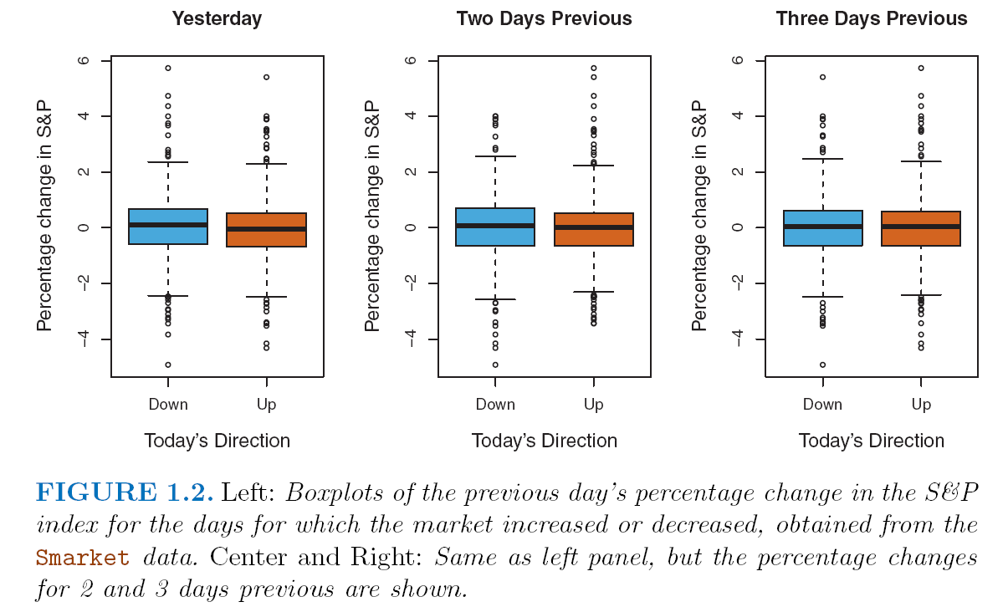
*********************************************************
***************************************************
That text is written by top-notch statisticians and scientists; it is a small miracle that this text is available for free. However, it is not really suitable as a textbook for this course because it assumes an advanced understanding of statistical topics. What it does very well is to provide step-by-step instructions in the use of R for sophisticated analysis. As the course goes on, we will make more and more use of the ISLR text.
No one is perfect, not even great statisticians. If you spend a few minutes examining the above graphs, I think that you will agree caption of that graph is not much help, nor are the axis labels. If you are courageous, you can read the ISLR text on that page carefully and figure it out. Better to wait, though, until I have introduced you in this lecture note to the statistical properties of stock return.

Section 2: Selecting, Downloading, and Transforming Stock Data

In this section, I will show how to download the daily price history of LGF (Light House Entertainment) since 1-1-2006, compute the percentage daily change in Excel, and save that file as a comma-separated-values file, csv. I strongly recommend you practice doing exactly what I do in the following steps and with LGF-A, too. Over 90% of student problems with downloading their own stock can be solved by simply making sure you get these steps right, with LGF-A. If you ask me for help with your download, the first thing I will ask is to see where the error occurred (or did not) when you practiced by downloading LGF-A.

STEP #1: Go to Yahoo Finance and type in LGF in the Yahoo Finance search box. I found I had a choice between LGF-A or LGF-B. I took LGF-A because it is a higher quality stock. That brings up summary information for LGF. Circled in the image below is “Historical Data”. Click on that!
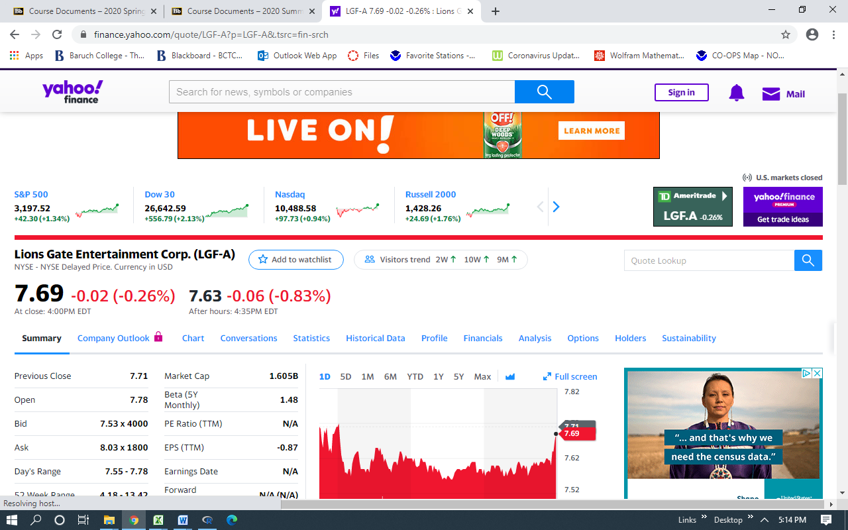

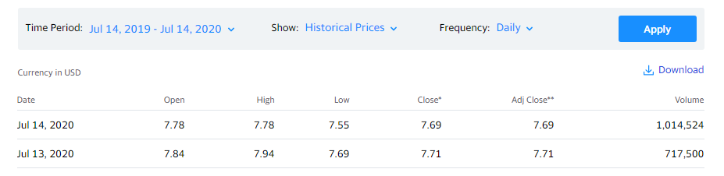
STEP #2: You will now find a screen that has data arranged as shown below. In blue font, note “Time Period,” “Historical Prices,” and “Daily.”
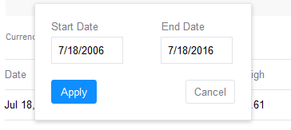
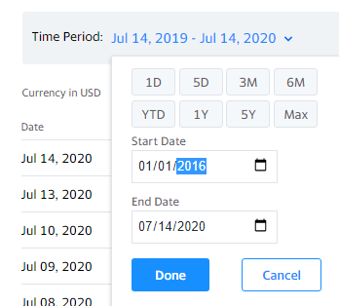
STEP #3: Click on the Blue dates of Time Period and change the starting date to 01-01-2006, as shown in the screenshot on the right. .

STEP #4: Click the Done box.

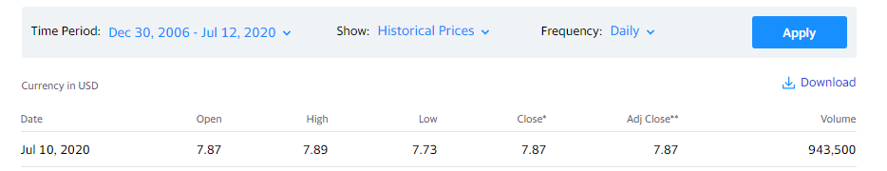
STEP #5: Check the Time Period dates, now. In this instance, my starting date changed to Dec. 30, 2006, from Jan. 1, 2006. I checked and I had in fact typed 01-01-2006. Life is full of surprises; thankfully, this one is inconsequential.

STEP #6: Click on the Apply button, shown above.

STEP #7: Count slowly to 12 or until you see the screen shift a little, which ever is longer.. Yahoo is busy preparing several thousand rows of data and that takes some time.

STEP #8: Click on Download, which is found just below Apply in the above image.

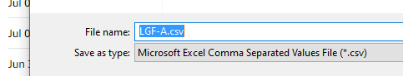
STEP #9A: Windows Users At the bottom left of the new screen, you will be notified that a csv (comma separated values) file has been downloaded, named LGF-A.csv.

Click save and then open the file with Microsoft Excel. In a Windows computer, the file will open by default in Excel, but on a Mac, it will open by default into Numbers.

STEP #9B: Mac Users: go to your Downloads. Left click once on the csv file, then right click. Then go to Open With and select Excel. A student recently showed me how to make Excel as your default option. After right clicking to open the menu, select Get Info and in that menu look down to “Open with”: change the entry there to “Microsoft Excel (default)”.

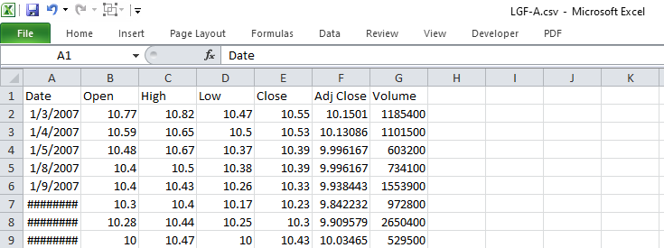
STEP #10: You will now have your csv file open in Excel. Check the first date on top: this should be close to January 1, 2006. My data starts on January 3, 2006, which doesn’t surprise me. From practice, I know stocks don’t trade on weekends and on New Year’s Day, so I will presume that January 2, 2006 was a Saturday or Sunday. BUT, if this was a serious project I would check. In data analysis, check everything you can because there are sure to be errors somewhere. Catch as many as you can; pray the rest don’t matter.
You will likely be worried by the hash marks: that just means the column needs to be widened .
STEP #11: Scroll down you have values up to the present time. Take a quick look for any missing data or other nonsense: that happens from time to time with Yahoo.

STEP #12: In the first empty column, add a column title. I used LGFret; the “ret” is for “return.” Don’t put a % symbol there: R will not like that.

This next step takes careful attention. We want to work with the Adjusted Close column, not the Close. We want to compute the percentage changes in the adjusted closing prices. Note that my Adjusted Close column is in column F. You will need to make the needed changes if yours is not in column F.
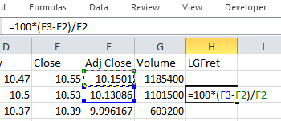
Starting in the third row of your “ret” column, enter the formula to compute the percentage change in the Adjusted Closing Price from yesterday to today:
=100*(F3-F2)/F2
which is 100 times the current adjusted price minus the previous adjusted price, divided by the previous adjusted price.
Please don’t try getting fancy by using Excel’s percent function, instead of multiplying by 100. Use the tried and true method shown..
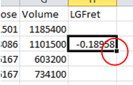

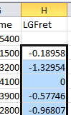
STEP #13: Slide your mouse to the lower right-hand corner of Cell H3, circled in the image on the right. Your cursor should now show a cross-hair symbol, which is not shown here. That cross-hair is called the “fill handle.” Double left click on the fill handle and Column H will fill with copies of your percentage change formula, down as far as values occur in column G.

STEP #14: Save the changes to your CSV file. There are several versions of csv file type available; save to the “simplest” type if you are on a Windows computer.

On a Mac, save your csv file to Microsoft csv. Otherwise, it may not load into R.

Now, you have your own personal stock data with daily percentage changes, or daily returns, ready to be loaded into R.

Section 3: Uploading Stock Returns to R
(7-14-20. I apologize for a change of company: the previous section shows updated commands, for which I happened to use LGF. This section is older and was written using IBM data as the example.)
I have posted my IBM.csv file, both Windows and Mac formats, so that you can follow the following steps, yourself. I urge you to do that, rather than just charging ahead with your own stock!
Begin by closing any csv file that you want to load into R. Importing data into R can be quite challenging, but it greatly simplified with a neat trick: place the csv file into the same “working directory” that your R installation is using. To find out where R has its current working directory, just type getwd( ) in R, short for “get working directory.”

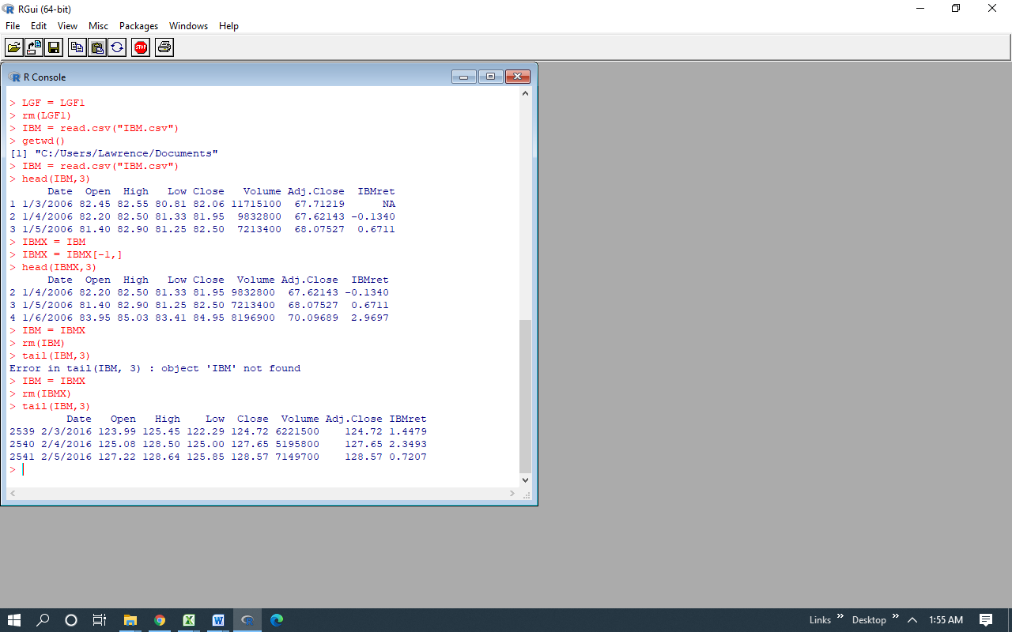
STEP #1:

STEP #2: Copy your csv file and paste into the working directory you got in Step #1.

STEP #3: Suppose you are loading a file named IBM.csv. Type in R

STEP #4: I now used the head( ) function as shown to get a look at the first 3 rows.
Section 4. Time Series Plots and Histograms in R

Here’s another way to look at the first rows, using the command, IBM[1:4, ]. Since the column space was left empty in that command, R will give us all columns.
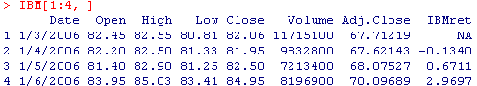

That looks good so far, but there is a problem in the IBMret column with an NA in the first row, where NA stands for missing value, or, technically, “not available”. Excel does not usually care about missing values, but many R functions hate to encounter an NA. A single NA may result in a cascade of NA output. (Many R functions have special arguments that will allow for ignoring NA values, but whenever possible get rid of the NA’s ahead of time, as the default setting is to not compute when an NA is present.)
So, let us immediately get rid of that NA by deleting the first row of IBM using a surprising subscripting option in R: negative subscripts. The following mysterious command takes out the first row of IBM, using the term
IBM[-1, ]
and then overwrites “IBM” without that row.
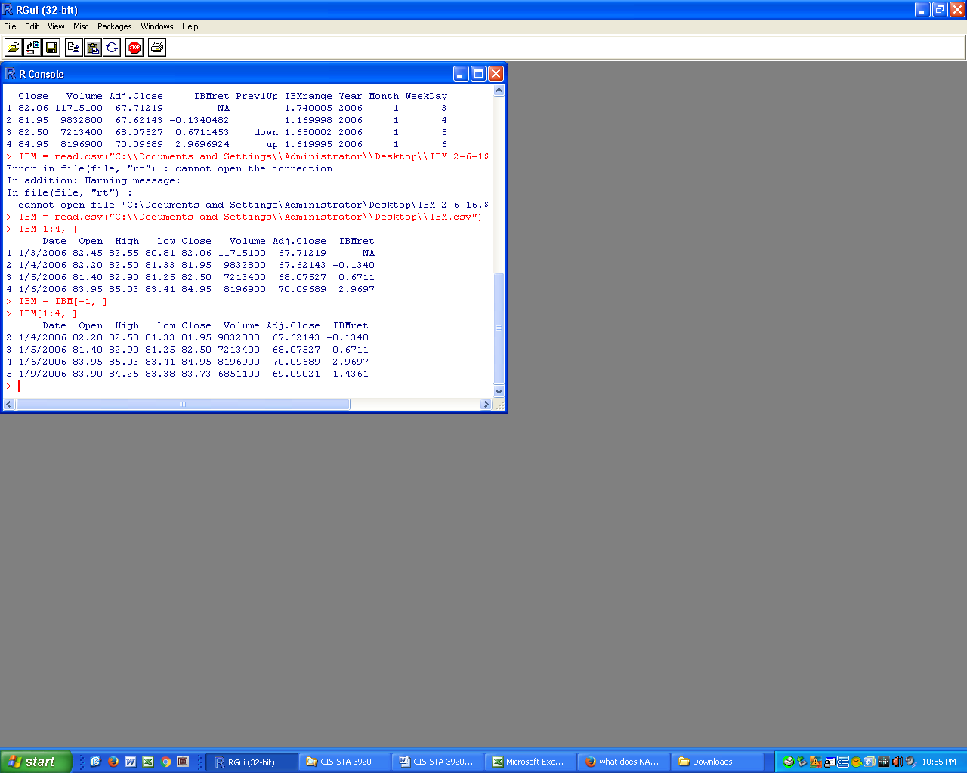

Let’s check and see if it worked. It did because that pesky NA is gone.

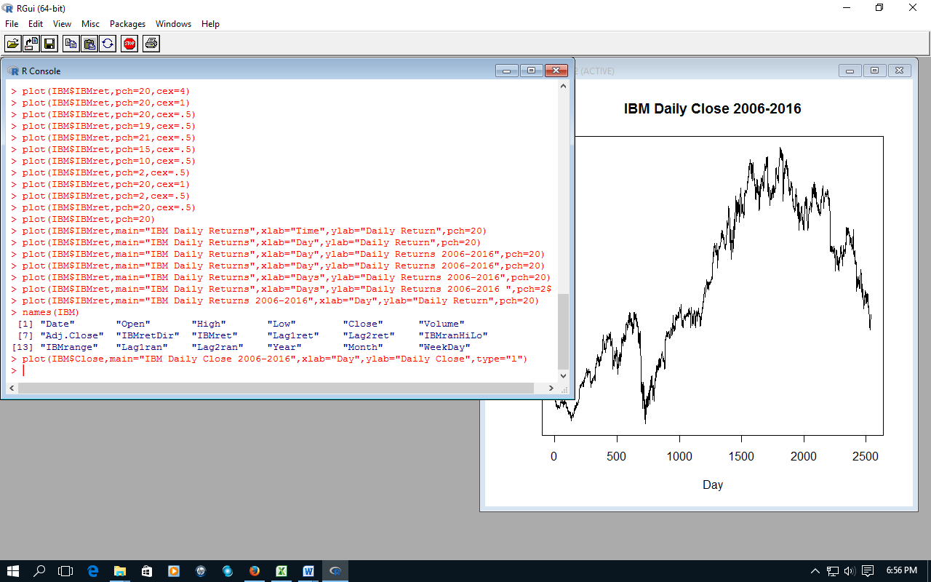
We are now going to plot the Closing prices for IBM. Is used the following rather complicated command, but you might want to start more simply with plot(IBM$Close) to get a feel for the process.

Now, in that command, be careful! That is the letter “l” (as in line) in the type argument, not the number 1.
For simplicity, I did not show the actual dates on the time axis, the x-axis. 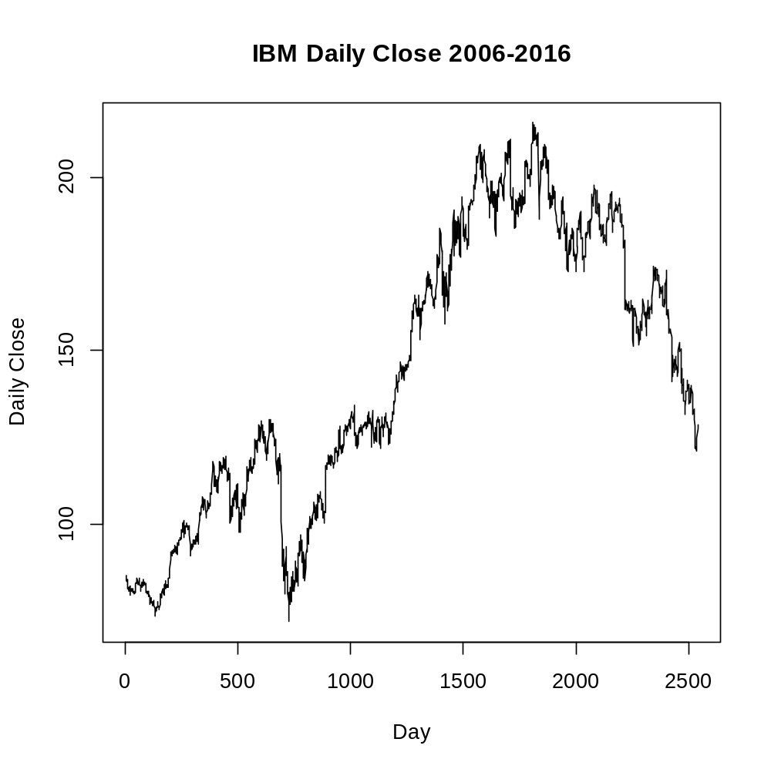

What are the characteristics of that plot? What you are seeing is an example of a random walk. Random walks are among those important and the most challenging of all forms of time series data. The first important thing to understand is that it does not make sense to compute the sample average or the sample standard deviation because there is no stable underlying population average to estimate, nor an underlying population standard deviation. And, since there is no single underlying probability distribution, computing a histogram is a waste of time! The problem is the underlying system that produces the closing prices is not stable across time. It is like weather data coming from a climate that is evolving rapidly across time, so rapidly that year’s temperatures are not informative about next year’s temperatures. That would be frightening climate.
Very often, we need to make a transformation of our data to get to a stable source, and that is the case here. We need a simple but powerful transformation: to go from closing prices to percentage change. (As noted before, we actually use adjusted closing prices to take into account stock splits and dividend payouts.) We will now see that this switch to percentage change makes an enormous difference in what we find.
First, let’s take a look at time series plot of the daily returns for IBM using the command,
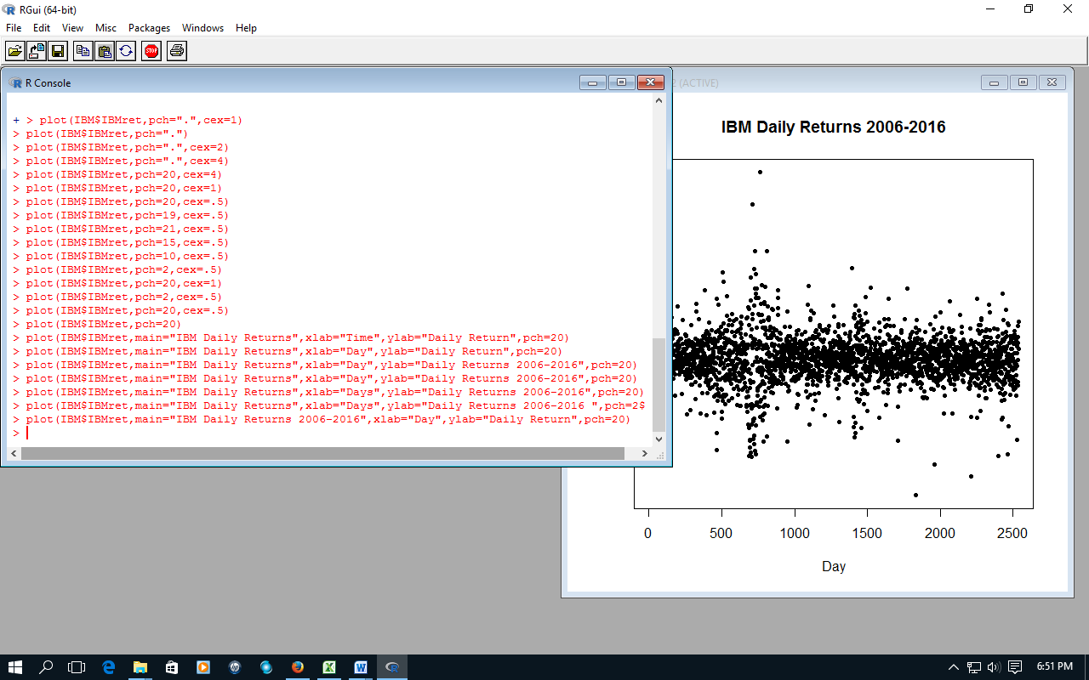

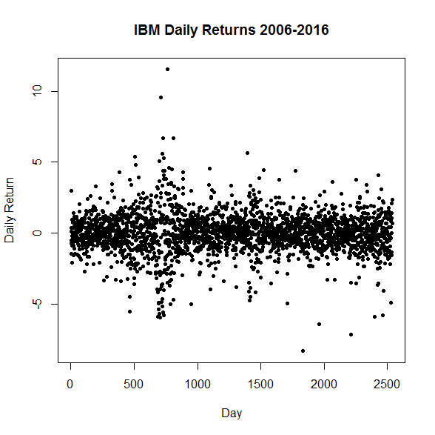

What are the characteristics of this time series plot? This looks a bit boring compared the time series plot of closing prices, but that is good! The points cluster around a central horizontal line. That line will lie a little above zero. The stability of the scatter of points around that line is graphical evidence that there is an underlying probability distribution of the daily return on IBM that is stable across time with respect to a single central value, μ. Looking back at the closing prices, we see no such single horizontal line around which closing prices concentrate.
While the variation in daily return is pretty consistent in patches, such as between Day 800 and Day 2400, it is obvious that around Day 700 (in the later months of 2008) that the variability of the daily return in IBM exploded. This is compelling evidence that while data-generating system may have a reasonably stable value of μ, the same cannot be said for the width of the underlying probability distribution: that changes dramatically across time! Recalling that the width parameter of a probability distribution is denoted as σ, we can see for ourselves that σ for the daily return on a stock shifts over time. The standard deviation of returns is a mainstay measure of risk in stocks.

We now wish to get two histograms, one for Close (closing price) and one for IBMret. To get a quick histogram, type

> hist(IBM$Close)

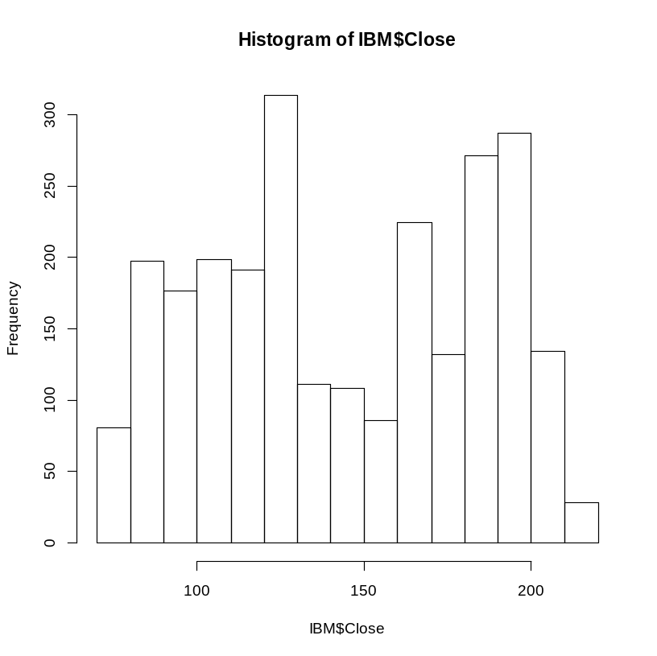
If you try this with your data and find very few bins with values, then it is likely that you have a missing value a the beginning or the end of your data. Check for it.
Does it look like that data is coming from an underlying probability distribution that has a bell-curve shape? No, it doesn’t. Is it reasonable to suggest that there is an underlying distribution with two peaks? Maybe, but in fact the closing prices of a stock do not arise from one probability distribution. Rather, there is a series of evolving underlying distributions called a stochastic process. What we have here is a smearing together of values which, in some sense, do not belong together in the form of a histogram. In the same way, we will see that the average of the closing prices is a terrible forecast of the next day’s closing price!
One way to show that there is no simple underlying bell curve that produces the closing price data is to use more bins for the histogram. That will let us see if there is firm evidence of a local bell curve underlying the “mound-shape” on the left half of the histogram. We can get more bins in the histogram by specifying the value of the breaks parameter. R was only giving us 15 bins, which is a little odd given we have about 2500 observations. Let’s go with 100 bins, which still provides a generous average of 25 observations per bin.
We write,
> hist(IBM$Close, breaks=100)

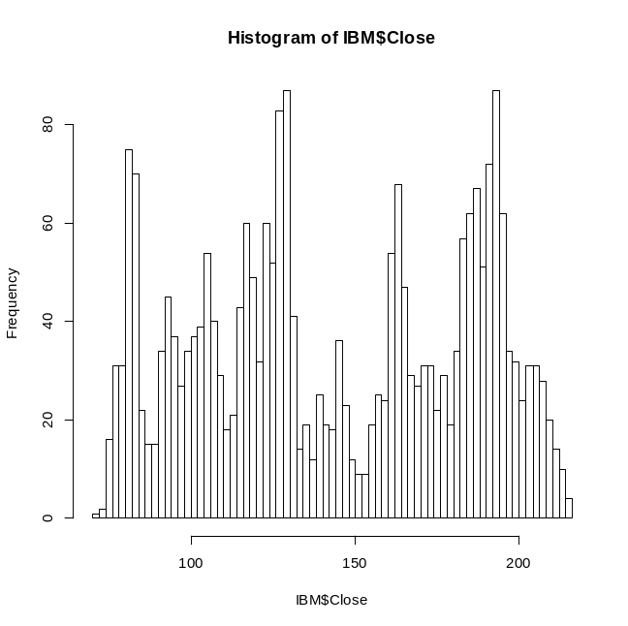

Wow, that mound on the left side has disappeared! These new spikes are not due to sampling variation (or “chance”). There really are local spikes, but those spikes do not point to local regions with higher probability of occurrence in the future. Note, too, how there is no sense of a “tail” of a bell curve on the left edge. This is because our closing prices wander around like a drunk, and that left edge is just the low point to which our drunk wandered before staggering back the other way, propelled by some puff of unforeseeable nothing.

The histogram of the IBM daily percentage return looks entirely different:

> hist(IBM$IBMret)

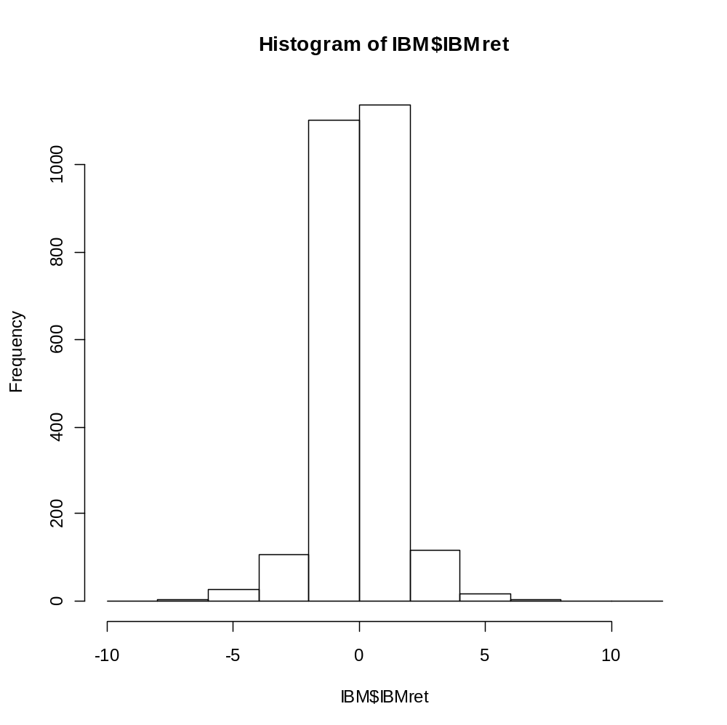
This looks far more like what we would expect if there existed an underlying Normal distribution. For example, this histogram implies, given the large sample size, the existence of an underlying distribution which is reasonably symmetric.
However, it appears that extreme values are more likely to occur than would be generated by a Normal distribution. That will be more obvious when we use more bins in the next view.

Here is a version with better titles and 50 bins. We can use a lot of bins with a sample size of 2500. Also, we can more easily see the extreme values with more bins.
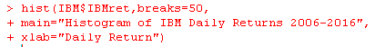

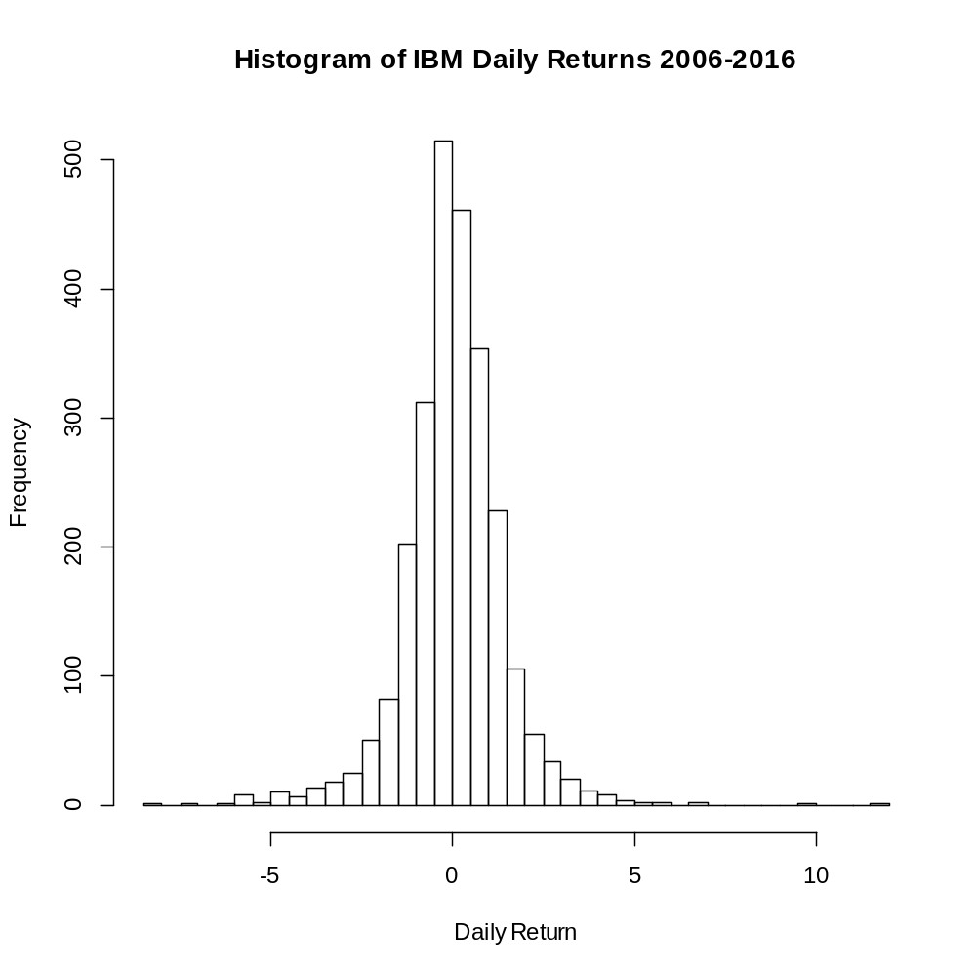

If we now got to 100 bins, we will still hold on to the same basic bell curved shape!

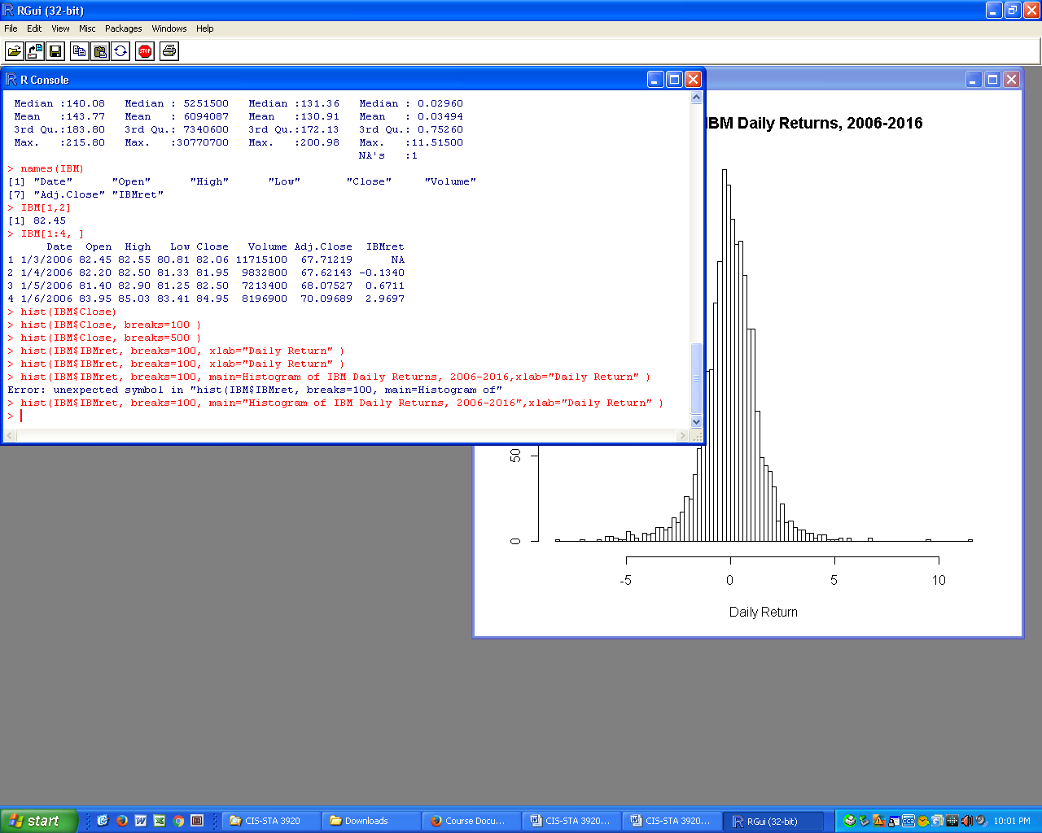

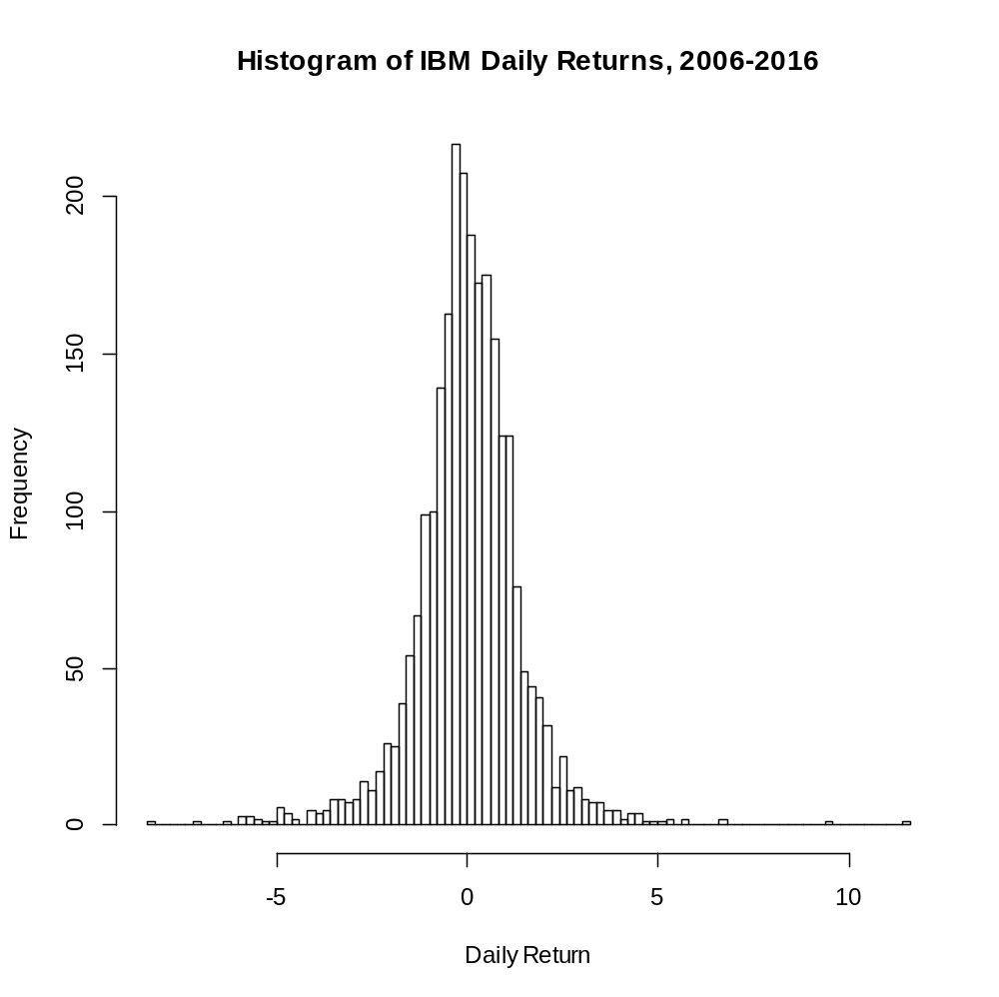

Here, we see that the overall bell-curved shape seen in the histogram for 15 bins has held up for 100 bins. This is evidence that there really is a bell-curved underlying probability distribution for daily returns on IBM.
However, as we saw in the time series plot, earlier, the standard deviation of that distribution, σ, is not constant across time. This also means that some of the long-tailed behavior in the above histogram comes about from combining time periods during which the population standard deviation was different.
Lecture Notes 2 Exercises

First, read through the lecture note. I recommend trying to execute all the steps I did, with the LGF and with IBM, before attempting these exercises.

Exercise 2.1. State the name of your company, its stock symbol, and tell me something interesting about the company. For motivation, pretend that you are preparing for a job interview with that company, tomorrow. Surely, you would want to demonstrate that you know something of genuine interest about your potential future employer!
Is it interesting that LGF makes movies and TV shows? A little bit interesting, but how about if you could casually throw in to the interview that your favorite movies made by LGF were those of the Hunger Games films directed by Francis Lawrence, and that you had been inspired to learn that he started off directing movie videos and that you wanted to work for a company that had the foresight and courage to let a fresh talent like his blossom, particularly given that his Hunger Games films have grossed over one billion dollars.
How long did it take me to come up with that? Twenty minutes, because I never hear of LGF and had to look that information up.

Exercise 2.2. Download your assigned stock data as instructed in Section 2, use Excel to compute percentage returns from the Adjusted Close, and import it into R. Delete the first row because of its missing value. Then, show
(a) The time series plot of your closing daily prices, showing proper titles;
(b) The times plot of your daily returns;
(c) Briefly discuss the differences between those two plots. In particular, which looks stable and which does not?
(d) Is your daily percentage return data coming from a source with a stable population standard deviation?

Exercise 2.3. Show
(a) The R histogram of your closing daily prices with default breaks, show proper titles;
(b) Increase the number of breaks to 100;
(c) Does increasing the number of bins (breaks) show that the data contains stable features or not?

Exercise 2.4. Show
(a) The R histogram of your daily returns with default breaks;
(b) Increase the number of breaks to 100;
(c) Does increasing the number of bins (breaks) show that the data contains stable features? That is, does it seem that the bell-curve is solid and it not a phantom?

Extra Credit Exercises

Exercise 2.5. Stock returns are often modeled in Finance as coming from an underlying Normal distribution. Generate 2500 standard Normal deviates.
(a) Show a time series plot of this series.
(b) Compare that against your time series plot of returns. Does this argue for or against using a Normal distribution as a model for stock returns?
(c) Show a histogram with a 100 breaks for this series.
(d) Comparing the shape of your histogram of returns and this new histogram, in what ways does a Normal distribution seem like a good model and in what ways is it not?

Exercise 2.6. A simple measure of variability (or risk) in stocks is the daily range, which is the daily high of Closing Price minus the daily low of Closing Price.
(a) In R, compute the daily range and explore its nature using the techniques you have practiced, above. Do not be alarmed that the histogram will be right-skewed.
(b) Take the logarithm of the range (R function log) and explore what happens with that, using the techniques and concepts in this lecture note..

